Trick or Treat  My name is Nathaniel.  I breathe through a tracheotomy tube.  I cannot say “Trick or Treat”  or “Thank You” or any words.  Thank you for understanding.  Happy Halloween!  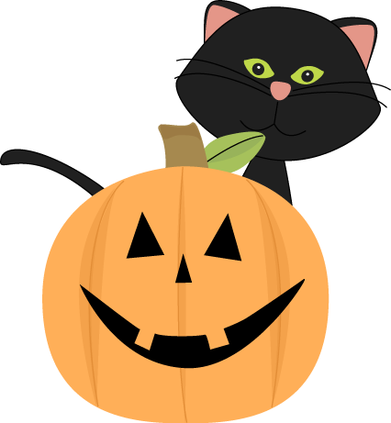 | Trick or Treat  My name is Nathaniel.  I breathe through a tracheotomy tube.  I cannot say “Trick or Treat”  or “Thank You” or any words.  Thank you for understanding.  Happy Halloween!
Trick or Treat  My name is Nathaniel.  I breathe through a tracheotomy tube.  I cannot say “Trick or Treat”  or “Thank You” or any words.  Thank you for understanding.  Happy Halloween! | Trick or Treat  My name is Nathaniel.  I breathe through a tracheotomy tube.  I cannot say “Trick or Treat”  or “Thank You” or any words.  Thank you for understanding.  Happy Halloween!

